# Electronic Medical Record Keeping System

Dustin Salentiny

Jeffrey Schafer

Jordan Torres

**MyHealth® System**

Spring 2010

# Table of Contents

**Electronic Medical Record Keeping System**

**Table of Contents**

**EMRKS -- Requirements Document**

0 Introduction

1    Accountants

1.1 Billing Reports

1.2    Process Payments

1.3    Verify Account Balance

2    Auditors

2.1    Billing Audit

2.2    Pharmacy Audit

3    Facility Staff

3.1    Rooms That Need Cleaning

3.2    Retrieve Equipment Move Requests

3.3    Find Equipment Location

4    Customer Support Personnel

4.1    Patient Scheduling

4.2    General Facility Questions

5    Nurses

5.1    Patient Record Retrieval

5.2    Patient Visitation Detail Submission

6    Patients

6.1    Patient History

6.2    Patient Scheduling

7    Pharmacists

7.1    Patient prescriptions

7.2    Pharmacological Inventory

8    Physicians

8.1    Patient Medical History

8.2    Patient Visit Details Submission

9    Receptionists

9.1    Patient Scheduling

9.2    Registering Payment

Appendix A Glossary

Appendix B Security

**EMRKS -- Design Document**

0    Introduction

1    Database Design

1.1    Database Structure (ER Diagram)

1.2    Schema Diagram

1.3    Schema Explanations

1.3.1    Physicians

1.3.2    Nurses

1.3.3    Receptionists

1.3.4    Pharmacists

1.3.5 Patients

1.3.6    Accountants

1.3.7    Drugs

1.3.8    Facility Staff

1.3.9    Patient_Visit

1.3.10    Prescription

1.3.11    Accounts_Payable

1.3.12    Hospital_Expenses

2    User Views and Prototypes

2.1    Account Creation/Authentication Windows

2.1.1 Account Creation Window

2.1.2    Authentication Window

2.2    Main Menu Window

2.3    Accountant Windows

2.3.1    Main Menu

2.3.2    Billing Reports

2.3.3    Process Payments

2.3.4    Verify Account Balance

2.4    Auditor Windows

2.4.1    Main Menu

2.4.2    Billing Audit

2.4.3    Pharmacy Audit

3 Performance Requirements

3.1    Development Environment

3.1.1    Database Software

3.1.2    Operating Systems/Server Software

3.1.3    Web Development Tools

3.2    Hardware Support

4 Backup and Recovery Requirements

5 Legal Issues

5.1    Privacy

5.2    Security

5.3    Legality

6    Full-Size ER Diagram

7    Full-Size Schema Diagram

**EMRKS -- Source Code**

0 Accountant.php

1 Auditor.php

2 Authenticate.php

3 Billingaudit.php

4 Billingreports.php

5 Body_end.php

6 Body_footer.php

7 Body_header.php

8 Body_start.php

9 Createaccount.php

10 Customersupport.php

11 Database.php

12 Facilitystaff.php

13 Footer.php

14 Header.php

15 Includes.php

16 Index.php

17 Login.php

18 Logout.php

19 Medicalhistory.php

20 Menu.php

21 Myaccount.php

22 Nurse.php

23 Patient.php

24 Patienthistory.php

25 Patientscheduling.php

26 Pharmacist.php

27 Pharmacyaudit.php

28 Physician.php

29 Print.css

30 Processpayments.php

31 Receptionist.php

32 Rxcheck.php

33 Rxinventory.php

34 Screen.css

35 Submitvisit.php

36 Validateaccount.php

37 Verifyaccountbalance.php

# EMRKS -- Requirements Document

Dustin Salentiny

Jeffrey Schafer

Jordan Torres

**MyHealth® System**

16 February 2010

### 0 Introduction

    The MyHealth system is an electronic medical record keeping system (EMRKS). An EMRKS is a system that provides a health care facility the ability to centralize and maintain their record keeping electronically. The MyHealth system will be built to help a hospital organize staff and patient information.  The system includes a webpage type interface which will contain multiple webpages to accommodate all the different pages for staff and customers alike. The interface will be connected to the database although will be invisible to the staff the actual database interface.  The staff will only have interaction with the webpages and the data that is generated from connecting to the database.  The system will also help with efficient access to information to all involved.The primary actors involved in the MyHealth System include: accountants, auditors, cleaning staff, customer support personnel, nurses, patients, pharmacists, physicians, or receptionists. All personnel will be defined below and each section will include typical scenarios for each.

The hardware required for this system will be: a few large servers with enough capacity to maintain all the data for patients' medical records, billing staff, and any other data that needs to be stored. The webpages built will be built upon separate servers and connected to the database servers via a network.

*Note: All users use the same style authentication screen.

### 1    Accountants

The MyHealth System recognizes an organization's need for proper billing and payment processing. Accountants primary goals include running billing reports, processing payments, and verifying account balances. After authentication, accountant users will see the options to do Billing Reports, Process Payments, and Verify Account Balance.

#### 1.1 Billing Reports

    Accountants will run billing reports each month for the organization. These reports are printed and mailed to patients and other organizations. On this screen, accounting users will enter the customers ID, which can be either their SSN or MYID, into the lookup box and see a report of all of the customer's charges in a line by line form. These screens are read-only.

#### 1.2    Process Payments

    Patients and organizations may send their payments in via mail or they may call their payments in. Accountants will process the payments through this system so they are logged as received. Once a payment has cleared, the balance of the account will be adjusted. This screen will show a list of all of the payments pending. These payment types range from checks to credit cards. After the payment has been processed and confirmed, the accounting user will press a confirmation button or if there is an error the user can give a reason for payment failure in a box provided and select the payment declined option and submit the form to be billed out to the customer (with reason for payment failure). These screens do have write access to allow confirmation of payment or in a payment failure, write access to post a notice in the customer's account warning of payment failure. These notes (confirmation or failure) will appear in billing reports.

#### 1.3    Verify Account Balance

    From time to time, patients and organizations may call in to verify their balances. Accountants will use the system to retrieve the inquirer's balance. By entering into a lookup box the customer's SSN or MYID, the accountant will be able to see the the customer's current balance and the line items on their bill.

### 2    Auditors

Auditors access the organization's billing records and expenses to see current and recent activity.  They are allowed to look but not modify any existing transactions or payments that does not compromise patient confidentiality. Auditors also verify the pharmacological stock matches purchase and prescription records. After authentication, the auditing user will see options to do a Billing Audit or a Pharmacy Audit.

#### 2.1    Billing Audit

Accessing expense data will be business expenses that the hospital incurs that is applicable to auditing. The billing audit screen will show all of the line items, their corresponding billable amount, and the amount a customer has paid toward the balance. This screen can be sorted by line item type or by date. This list will be read only.

#### 2.2    Pharmacy Audit

    Accessing and tracking prescriptions and pharmacological stock. The pharmacy audit screen will show, for each pharmacological item, the pharmacy's purchased amount, the current inventory amount, and the amount prescribed. The audit user will be able to view an entire history of a pharmacological item by selecting it from the list. This history will show chronologically the inventory levels, including purchases, prescriptions, or expirations.

### 3    Facility Staff

    One of the most important priorities for any medical facility is the cleanliness of its rooms. Facility staff primary goals are to clean rooms soon after being vacated, make sure equipment is the proper location, and find equipment that has been requested. After authentication, the facility staff will see options to look up rooms that need cleaning, retrieve equipment move requests, and find equipment location.

#### 3.1    Rooms That Need Cleaning

   Rooms that are assigned the need for cleaning with a description of the type of cleaning (equipment, floors, bedding, etc) shall be kept in an updated list that is easily marked off by staff as they are done with completion of cleaning. On this screen, the facility staff will be able to see the rooms that need cleaning. After service has been rendered, the user will select the room completion option or select the an option to detail why a room is not clean. Such circumstances may be: the room has a leaky room, the bathroom sink is broken, a floor tile is cracked, etc. Once the room has been repaired, the user will select the room completion option to notify the system of a room available.

#### 3.2    Retrieve Equipment Move Requests

    Medical staff need equipment and materials to be in a room. The request specifies the equipment and to the room to which it should be moved. The screen will be an ordered list of equipment move requests. The list will be a first come, first serve order. Once the request has been completed, the facility user will choose the request completed option and then next request will be shown.

#### 3.3    Find Equipment Location

    An online look up system shall be implemented to allow staff to look up equipment location quickly at any network accessible location. This screen will ask for the major equipment ID or equipment name and display a list of equipment and its location. This screen is read only.

### 4    Customer Support Personnel

    Customer Support Personnel include such people as receptionists and staff that are allowed access to things such as patients' appointment times and any cancellations or rescheduling as necessary.  They will not be allowed access to private files such as patient medical history without approved permission or authorization. Customer Support Personnel also take phone calls for the organization to redirect or answer general questions. After authentication, the customer support personnel will see options to do patient scheduling or answer general facility questions.

#### 4.1    Patient Scheduling

   Customer support personnel are allowed to view appointment times for doctors as patients call in to make appointments/cancellations and at the hospital where the patients are leaving/arriving. Customer support personnel are able to access a patient's schedule after entering the patient's SSN or MYID into a lookup box and submitting it. Once the patient records are visible, the customer support user will select a doctor or date, enter the amount of time needed with the doctor and then can view available times for either the date or the doctor. Once an time has been agreed upon, the user will confirm the appointment by selecting the schedule button. Customer support personnel are then able to update their requests for them if necessary.

#### 4.2    General Facility Questions

    Customers ask questions regarding patient records or visit information. Support personnel will ask verification questions before giving out patient information, which may include records transfer to another facility or verification of previous patient visit. This screen will have a lookup box for the customer support user to enter the patient's MYID or SSN. After verification, the screen will display all of the patient's history. If the patient makes a request to transfer records, there will be an option to make a transfer request, which the customer support user will fill out the receiving institution's name and address and then submit it to be recorded in the patient's history. The customer support user will have to manually fax the patient's records to the requested institution; this process takes place outside of the MyHealth System.

### 5    Nurses

Nurses are responsible for the well-being and early seeing of the patients.  As such they will have access to the patients files to prep them before being seen by a doctor or physician. Nurses also enter details about their interactions with patients. After authentication, nurses will be able to do patient record retrieval and do a patient visitation detail submission.

#### 5.1    Patient Record Retrieval

   After logging in and entering the patient's SSN or MYID, nurses will have similar access to patient files as doctors will in regards to updating and modifying new data such as allergies, history and other relevant medical data. On this screen, nurses will see the entire history of the patient on one screen. This screen is read only.

#### 5.2    Patient Visitation Detail Submission

    Nurses and doctors are required to enter details from the patient's visit. After entering the patient's MYID or SSN, nurses will be able to enter the details of the visit into the patient's record. This data includes: height, weight, blood pressure, heart rate, reason for visit, medications currently on, and other visitation details. Once complete, the form is submitted and cannot be edited.

### 6    Patients

Patients are the primary focus of this system.  They are the ones tended to and need to have access to their own files but no one else's.  They also should be able to see their files online and to schedule/cancel appointments online, pay bills etc.

#### 6.1    Patient History

An online viewing system (this is a part of the MyHealth EMRKS) will be set up with authorization that the patient can review their own medical history and medical files. Patient history will include all relevant medical history data.  Relevant medical history includes: blood pressure, cholesterol, height, weight, surgeries, date of visit, prescribed medicine, notes, and allergies.

#### **6.2    Patient Scheduling**

Patients will, with proper authentication, be able to view their upcoming appointments and request to modify them to cancel/reschedule according to time-slots available with their doctor/physician. Upon approval they will receive an email, mail, or telephone call notifying them of the changes.

### 7    Pharmacists

Pharmacists are responsible for the administration of drugs with proper forms given by a doctor.  As doctors fill out prescriptions (online or by paper) the pharmacists are allowed to check and see prescriptions for patients and give out the medicine as needed. Pharmacists will also need to update inventory when new shipments arrive.

#### 7.1    Patient prescriptions

Pharmacists will have limited access to an online page to see if the patient has the requested prescription approved by the doctor or not. The doctor must have administered it, and approved it, then marked a check box to authorize it as a digital signature. The pharmacist will be able to log in and put in the patient's SSN or MYID and be able to pull up their past and current prescription requests along with who administered them, known patient drug interactions, the dosage, the medicine and the digital signature from the prescribing doctor. When a prescription has been entered, the prescription will be checked for known drug interactions or existing medical conditions. As prescriptions are filled, inventory is automatically updated as the pharmacist must close out the request for the medicine by either allowing it or denying it.

#### 7.2    Pharmacological Inventory

    Pharmacists will need to maintain an up-to-date inventory. When new stock arrives, it will need to be entered into the system in a spreadsheet type format page online.  There will be a page which will tell of current medical stock, if the pharmacist wants to make any changes, and an update section will allow them to increase stock as new stock comes in.

### 8    Physicians

Physicians are responsible, along with nurses, for caring for the patients.  As the doctors see patients they will have access to patient medical history and be responsible for electronically logging the details of the most previous patient visit.  However, they will not have access to things such as patient financial information.  Physicians will enter patient visit details after the visitation has ended.

#### 8.1    Patient Medical History

   Upon authentication with the system, the physician is able to see all the patients medical history in one easy access view.  The easy access view will contain patient history with the current hospital, and any other history that can be obtained by collaboration with other hospitals.  In the patient history there will be things such as: previous surgeries with date, type, and doctor operating; previous prescriptions with what type of medicine and when it was administered; previous height, weight, cholesterol, blood pressure, and any other relevant medical data history.

#### 8.2    Patient Visit Details Submission

    After the visitation has completed, the physician will log into the system using their SSN or MYID and password and enter their comments and details of the visit into the system of the patient.  Upon patient exit the physician will open up the patient's current visit detail page and will be able to jot down notes electronically using a standard keyboard to make any useful notes or references of the current visit.

### 9    Receptionists

Receptionists are responsible for maintaining the scheduling of patients with the nurses and physicians.  They should be allowed to update the scheduling but not see things such as patient medical history. Receptionists sometimes will need to handle patient payment requests.  Receptionists, after logging in, will be able to access a screen which will allow them to enter a patient's SSN or MYID which will grant them an easy access view of the patient's schedule.

#### 9.1    Patient Scheduling

   Receptionists are able to access a patient's schedule after entering the patient's SSN or MYID into a lookup box and submitting it. They are then able to update their requests for them if necessary.  If the patient has electronically requested an update the receptionist is responsible for allowing the change and notifying the patient and personnel necessary. As requests come in the receptionist will be able to confirm or deny the updated change.  After either is selected the patient will be notified via email and telephone to let the patient know what decision they made and why.

#### 9.2    Registering Payment

    A patient may pay during their visit. The payment must be logged and pended to their account. Payment processing is done by accountants.  If a patient is willing to pay during a visit to the hospital they may pay the receptionist.  The receptionist is able to log into the system and access a patients billing screen by entering their SSN or MYID.  From the billing screen they are able to update pending payments as the balance is adjusted with confirmed payments.

### Appendix A Glossary

**account** A "family" unit--all family members are under one account. Any member of the account may access any other member's information.

**audit** A process of verifying the current state against the changes since a previous state.

**billing report** A printout of a customer balance statement.

**EMRKS**    Electronic Medical Record Keeping System: a system that provides a health care facility the ability to centralize and maintain their record keeping electronically.

**history** Any and all previous patient/organization interactions.

**line items**A line in a billing report that corresponds to a billable item, i.e. an allotment of a doctor or nurse's time, any medical supplies, or a laboratory.

**log** Any interaction with a customer/patient must be logged/documented to their account.

**lookup box**A small box where the customer's SSN or MYID is entered, once the search button is pressed the data entered into the lookup box will be used to search for the customer's account.

**MYID**The MyHealth System ID. e.g., 1000239483.

**organization** An organization is an entity that interacts with the MyHealth System, such as a supplier, business, etc.

**patient** An entity that is a registered user of the facility, with at a minimum of one in-progress or scheduled and completed visit with a medical professional.

**payment** A mailed check, credit card either via phone or in person, or cash tendered at a reception desk.

**pharmacological stock unit** A base unit in which the drug arrives. For example, a pill is one unit; fluid milligram is one unit.

**prescription** A nurse/physician entered log that specifies a time and/or unit limit of a pharmacological stock unit.

**room** A room is divided up into its smallest usable size. A double-room is two units; a triple-room is three units.

**scheduling** A patient may be scheduled to a billable employee, if the billable employee is active/scheduled to work.

**screen**A page or window that a user utilizes to interact with the system.

**SSN**A US Social Security Number. e.g., 123-45-6789.

**terminal** An instance of the MyHealth System interface usable on a organization workstation or home computer.

**time unit** All employees billable time unit is on the minute system. For example, .5 hour is 30 units (minutes); 2 hours is 120 units (minutes).

**user** A user may be a physician, nurse, patient, etc. Each user type will have specific verification of identity specified in Appendix B.

**verification** A system the organization uses to verify the identity of a user.

**visit** A visit begins when the patient is registered. The visit ends when the patient is either discharged or after the nurse/physician escorts patient back to a waiting room.

**window** An area where user-type specific work is performed.

### Appendix B Security

    The MyHealth System utilizes abstract layers of security. The two primary security layers are database and interface. Each layer has secondary levels to further limit access or possible privacy violations. Security of private information is a high priority of the MyHealth System.

    The database layer will have secondary layers to allow user types to access or modify certain areas of the database. This also prevents users to view or edit areas of the database they do not have permission to access or modify. By limiting access at the database layer also limits the amount of damage done in the event of nefarious activities at a terminal.

The compounds of the interface security layer are derived from authentication of users to access the system and see level specific information.  The authentication process is in the form of passwords or pin numbers to allow users to access certain aspects of the MyHealth System and restrict them from access to others. This system ensures that only the individuals that know the account credentials may access that account.

    The aforementioned security protocols were developed to be as transparent as possible while still allowing for maximum patient privacy. By limiting access at a user-type level, the security requirements are reduced for higher layers. By having interface-level security, the number of windows available to a user is limited--which further restricts their actions to the bare-essential screens that user type needs to accomplish their goal. These layers function much like a tree-branching system function. The trunk is the widest access and the primary branches have only specific access to the main trunk. Likewise, the secondary functions only have access to specific parts of the primary branches.

# EMRKS -- Design Document

Dustin Salentiny

Jeffrey Schafer

Jordan Torres

**MyHealth® System**

25 March 2010

0    Introduction

The goal for the second delivery for the database course is a document that explains the database design, user views and prototypes, performance requirements, backup and recovery requirements, and legal issues of the electronic medical record keeping system.

The database design is presented in different formats to develop an understanding of what is included in the database and the relations that tie it all together.  The ER diagram shows how the entities interact with each other.  The schema shows all the tables and fields included within this schema and how they relate to each other.  The fields in the schema are tied together with lines showing their relations.  The prototypes are presented as an illustration of how the interface will actually be presented to the employees, staff, and patients.  The interface is delivered as an easy-to-use online web-based system that will pull data from the database while maintaining a layer of security.  Users of the interface will not be allowed to actually interact with the database directly, they will do it through the interface prototypes below.

Performance requirements will explain what necessary hardware and software components will be required to implement the entire web-interface, database, and security aspects which make up the overall design of the MyHealth system.  With the hardware and software are also included the backup and recovery requirements to maintain a functional system which will maintain the integrity of the system in case of unexpected hardware failures.

Finally the legal issues section will discuss the necessary security and authorization design aspects that will be implemented to make sure that data integrity and confidentiality is maintained and that no employee or patient should be able to access information outside of specified bounds.

## 1    Database Design

    1.1    Database Structure (ER Diagram)

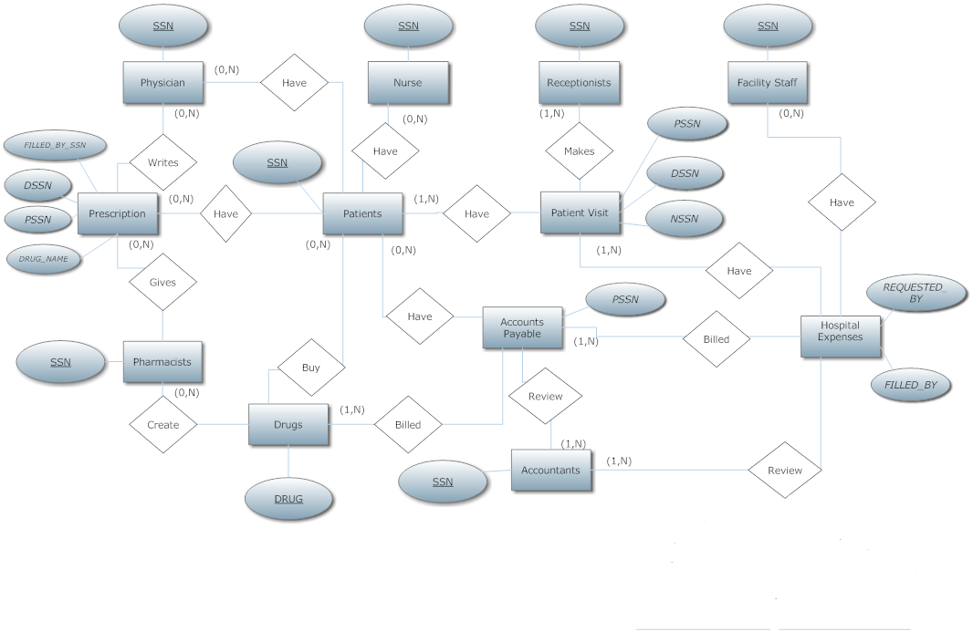

**Figure 1 --** Entity-Relationship diagram.

This Entity-Relationship diagram depicts the many different aspects that make up the design of the system.  As the entities are related to other entities there are relations describing the connection that the entities have.  This ER diagram is simply a brief overlay of how the whole design of the system is supposed to work.

    1.2    Schema Diagram

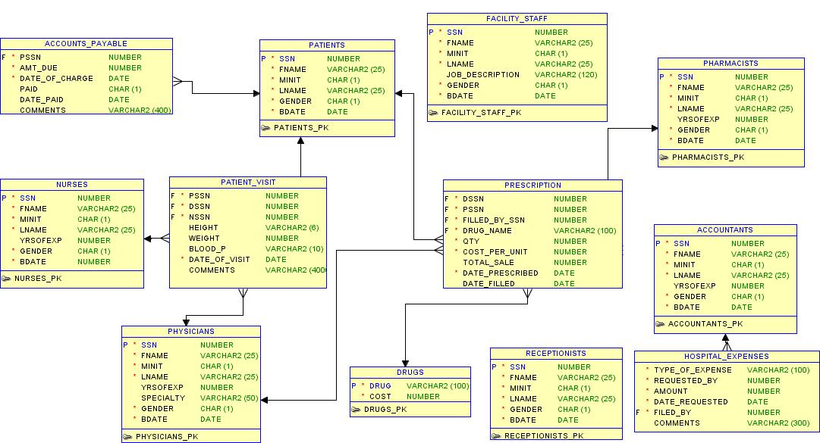

**Figure 2 --** Schema diagram. (See Section 7 for a full-size version.)

The schema diagram is proposed to show the actual physical database entities of the system.  It shows the necessary tables required for the system and their corresponding attributes.  It also shows which attributes are primary keys, or foreign keys.  The arrows drawn indicate that a foreign key in one table comes from a primary key in the table that the arrow points to.  The importance of this is for database administrators and developers to understand the necessary tables and attributes required to store the necessary data in the MyHealth system.

    1.3    Schema Explanations

#### 1.3.1    Physicians

***PHYSICIANS***

| SSN | PK |
| --- | --- |
| FNAME |  |
| MINIT |  |
| LNAME |  |
| YRSOFEXP |  |
| SPECIALTY |  |
| GENDER |  |
| BDATE |  |

SSN -- Social Security Number that uniquely identifies every physician.

FNAME --  First name of the physician.

MINIT -- Middle initial of the physician.

LNAME -- Last name of the physician.

YRSOFEXP -- Years of professional experience the physician has.

SPECIALTY -- Special practice the physician is in.

GENDER -- Gender of the physician.

BDATE -- Date of birth of the physician.

#### 1.3.2    Nurses

***NURSES***

| SSN | PK |
| --- | --- |
| FNAME |  |
| MINIT |  |
| LNAME |  |
| YRSOFEXP |  |
| GENDER |  |
| BDATE |  |

SSN -- Social Security Number that uniquely identifies every nurse.

FNAME -- First name of the nurse.

MINIT -- Middle initial of the nurse.

LNAME -- Last name of the nurse.

YRSOFEXP -- Years of professional experience the nurse has.

GENDER -- Gender of the nurse.

BDATE -- Date of birth of the nurse.

#### 1.3.3    Receptionists

***RECEPTIONISTS***

| SSN | PK |
| --- | --- |
| FNAME |  |
| MINIT |  |
| LNAME |  |
| GENDER |  |
| BDATE |  |

SSN -- Social Security Number that uniquely identifies every receptionist.

FNAME -- First name of the receptionist.

MINIT -- Middle initial of the receptionist.

LNAME -- Last name of the receptionist.

GENDER -- Gender of the receptionist.

BDATE -- Date of birth of the receptionist.

#### 1.3.4    Pharmacists

***PHARMACISTS***

| SSN | PK |
| --- | --- |
| FNAME |  |
| MINIT |  |
| LNAME |  |
| YRSOFEXP |  |
| GENDER |  |
| BDATE |  |

SSN -- Social Security Number that uniquely identifies every pharmacist.

FNAME -- First name of the pharmacist.

MINIT -- Middle initial of the receptionist.

LNAME -- Last name of the receptionist.

YRSOFEXP -- Years of professional experience the pharmacist has.

GENDER -- Gender of the pharmacist.

BDATE -- Date of birth of the pharmacist.

#### 1.3.5 Patients

***PATIENTS***

| SSN | PK |
| --- | --- |
| FNAME |  |
| MINIT |  |
| LNAME |  |
| GENDER |  |
| BDATE |  |

SSN -- Social Security Number that uniquely identifies every patient.

FNAME -- First name of the patient.

MINIT -- Middle initial of the patient.

LNAME -- Last name of the patient.

GENDER -- Gender of the patient.

BDATE -- Birth date of the patient.

#### 1.3.6    Accountants

***ACCOUNTANTS***

| SSN | PK |
| --- | --- |
| FNAME |  |
| MINIT |  |
| LNAME |  |
| YRSOFEXP |  |
| GENDER |  |
| BDATE |  |

SSN -- Social Security Number that uniquely identifies every accountant.

FNAME -- First name of the accountant.

MINIT -- Middle initial of the accountant.

LNAME -- Last name of the accountant.

YRSOFEXP -- Years of professional experience the accountant has.

GENDER -- Gender of the accountant.

BDATE -- Date of birth of the accountant.

#### 1.3.7    Drugs

***DRUGS***

| DRUG | PK |
| --- | --- |
| COST |  |

DRUG -- Unique identifier for each drug which is the drug name.

COST -- The current cost of the drug.

#### 1.3.8    Facility Staff

***FACILITY_STAFF***

| SSN | PK |
| --- | --- |
| FNAME |  |
| MINIT |  |
| LNAME |  |
| JOB_DESCRIPTION |  |
| GENDER |  |
| BDATE |  |

SSN -- Social Security Number that uniquely identifies every facility staff.

FNAME -- First name of the facility staff member.

MINIT -- Middle initial of the facility staff member.

LNAME -- Last name of the facility staff member.

JOB_DESCRIPTION -- Job description of the facility staff member.

GENDER -- Gender of the facility staff member.

BDATE -- Date of birth of the facility staff member.

#### 1.3.9    Patient_Visit

***PATIENT_VISIT***

| PSSN | FK references SSN in PATIENTS |
| --- | --- |
| DSSN | FK references SSN in PHYSICIANS |
| NSSN | FK references SSN in NURSES |
| HEIGHT |  |
| WEIGHT |  |
| BLOOD_P |  |
| DATE_OF_VISIT |  |
| COMMENTS |  |

PSSN -- Foreign key that links the visit to the patient.

DSSN -- Foreign key that links the visit to the administering physician.

NSSN -- Foreign key that links the visit to the overseeing nurse.

HEIGHT -- Height of the patient at the current patient's visit.

WEIGHT -- Weight of the patient at the current patient's visit.

BLOOD_P -- Blood pressure of the patient at the current patient's visit.

DATE_OF_VISIT -- Date of the visit of the patient to the care facility.

COMMENTS -- Place for the doctor/nurse to describe any additional comments about the visit.

#### 1.3.10    Prescription

***PRESCRIPTION***

| DSSN | FK references SSN in PHYSICIANS |
| --- | --- |
| PSSN | FK references SSN in PATIENTS |
| FILLED_BY_SSN | FK references SSN in PHARMACISTS |
| DRUG_NAME | FK references DRUG in DRUGS |
| QTY |  |
| COST_PER_UNIT |  |
| TOTAL_SALE | QTY x COST_PER_UNIT |
| DATE_PRESCRIBED |  |
| DATE_FILLED |  |

DSSN -- Foreign key of physician who wrote the prescription.

PSSN -- Foreign key of patient receiving the prescription.

FILLED_BY_SSN -- Pharmacist that filled the prescription.

DRUG_NAME -- Foreign key of the drug name that the prescription was for.

QTY -- Amount of drug that was given to the patient.

COST_PER_UNIT -- The price of the drug at the time it was filled.

TOTAL_SALE -- The amount that was billed to the patient per quantity and cost per unit.

DATE_PRESCRIBED -- The date that the physician wrote the prescription.

DATE_FILLED -- The date that the prescription was filled at the pharmacy.

#### 1.3.11    Accounts_Payable

***ACCOUNTS_PAYABLE***

| PSSN | FK references SSN in PATIENTS |
| --- | --- |
| AMT_DUE |  |
| DATE_OF_CHARGE |  |
| PAID |  |
| DATE_PAID |  |
| COMMENTS |  |

PSSN -- Foreign key referencing the patient's social security number.

AMT_DUE -- The amount for the charge that is accrued.

DATE_OF_CHARGE -- The date that the charge has been put on their bill.

PAID -- The paid section indicates whether the bill has been paid or not.

DATE_PAID -- The date paid is the date that the payments were received.

COMMENTS -- The comments section is for any other additional comments that might go along with a payment.

#### 1.3.12    Hospital_Expenses

***HOSPITAL_EXPENSES***

| TYPE_OF_EXPENSE |  |
| --- | --- |
| REQUESTED_BY | FK SSN of any of the tables PHYSICIANS, ACCOUNTANTS, or NURSES |
| AMOUNT |  |
| DATE_REQUESTED |  |
| FILLED_BY | FK SSN of ACCOUNTANTS table |
| COMMENTS |  |

TYPE_OF_EXPENSE -- The expense type being what the expense is for.

REQUESTED_BY -- The unique identifier of the person requesting the item.

AMOUNT -- Amount requested for the expense.

DATE_REQUESTED -- The date that the item was requested.

FILLED_BY  -- Which accountant made the transaction to fill the request.

COMMENTS -- Any additional comments about the expense.

## 2    User Views and Prototypes

### 2.1    Account Creation/Authentication Windows

#### 2.1.1 Account Creation Window

Future patients can be referred to the website to create an account for future interaction with the medical facility. Employees of the facility will have accounts created by an administrator that can give them the appropriate permissions in the system. On this window, the editable fields are all related to their personal and identifiable information. After the user passes the anti-bot check, they will be shown an account created window and will be allowed to log into the system.

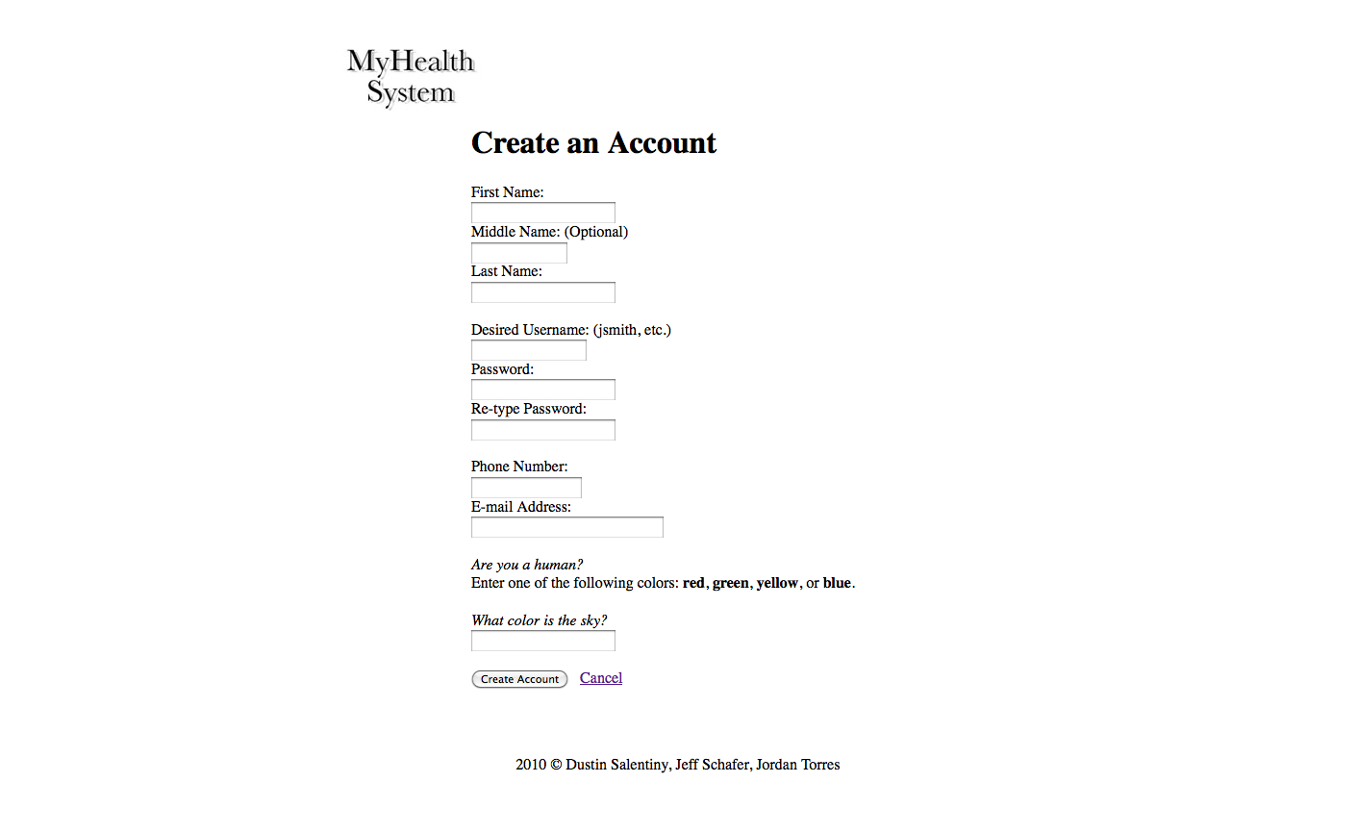

**Figure 3 --** Prototype account creation window.

#### 2.1.2    Authentication Window

The first page that any user will see is the authentication window. The user will enter their username and password. Then click on 'Login'. If their password is correct, they will see the main menu. If their password is incorrect, they will see the error message 'Incorrect password.' and be returned to the authentication window. If their username is incorrect, it will display an error message 'Username is incorrect.'.

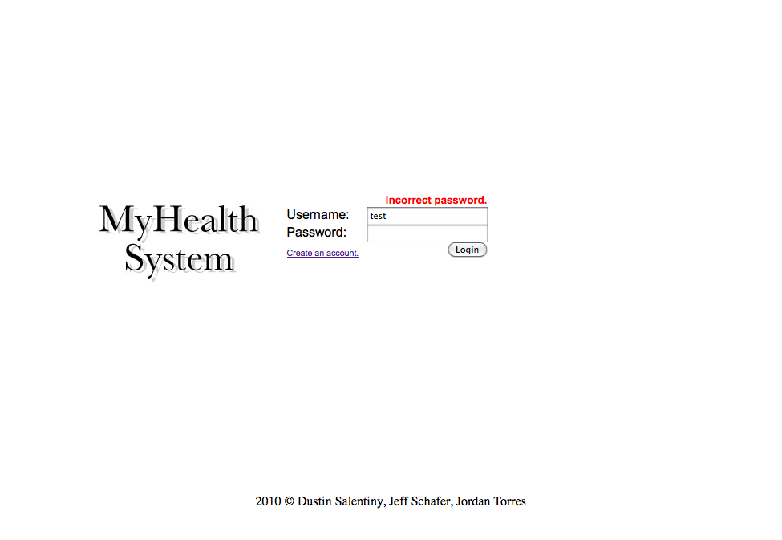

**Figure 4 --** Prototype authentication screen.

### 2.2    Main Menu Window

The main menu is where users will land after successfully authenticating. Since some users have multiple roles in a medical facility they will be shown multiple choices of roles to choose from, depending on their task. Users that only have one roles will be directed to their respective roles automatically and they will bypass this screen. The left-hand menu shows all of the roles the user is able to perform. Choosing one of the roles will allow the user to enter the role and see the main menu for that role. A user can either select a role on the left-hand menu or they can log out. Either option leaves the main menu.

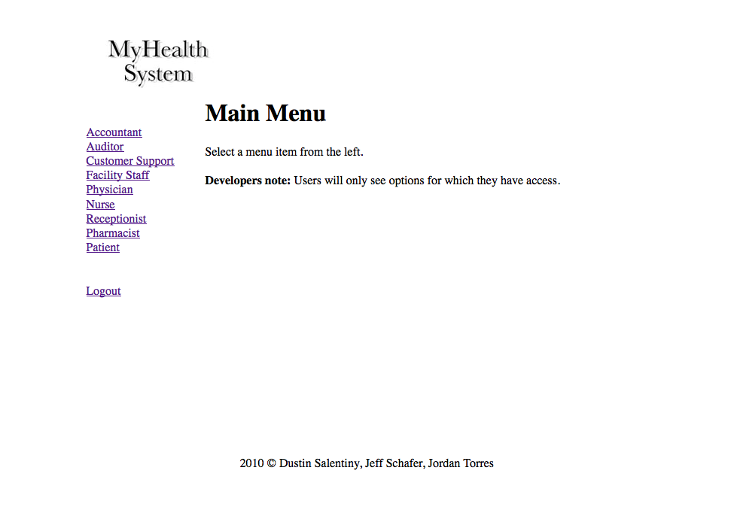

**Figure 5 --** Prototype main menu screen capture.

### 2.3    Accountant Windows

#### 2.3.1    Main Menu

The accountant main menu is the primary landing page for the accountant role. From this page the user will be able to select one of three options. Billing Reports, Process Payments, and Verify Account Balance are the three choices in the center of the screen. Select either of the choices sends the user to the respective page for further work. The other available options are to leave this page via selecting a different role or clicking on the the 'Logout' link on the left-hand menu.

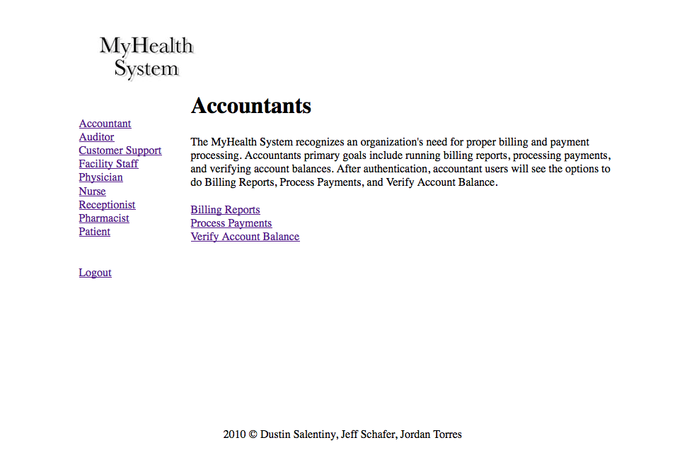

**Figure 6 --** Prototype accountant main menu.

#### 2.3.2    Billing Reports

The accountant task billing reports is how the user will generate a billing report for an individual patient. By entering a patient ID (SSN) and clicking on 'Find Billing Report', the system will retrieve a list of billing items from the accounts_payable table. The items are billable items assigned to the patient. If the patient ID is not found, the system will display an error 'No patient found.' or if there are no billable items for the patient 'No outstanding billable items.'.

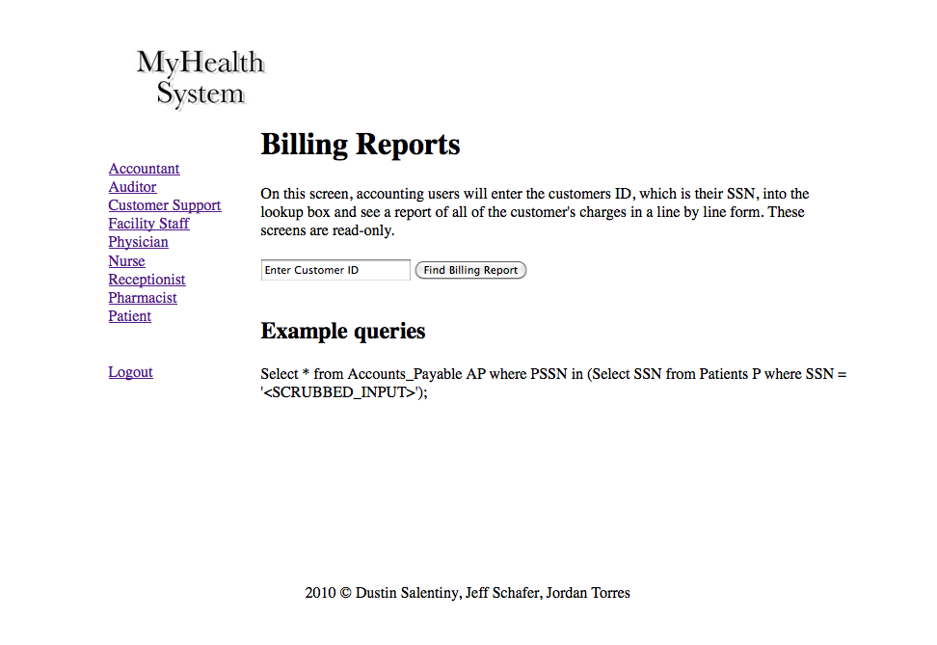

**Figure 7 --** Prototype accountant billing report window.

#### 2.3.3    Process Payments

The accountant task process payments is how the user will credit, debit, authorize, or deny payments to a patient account. The accountant user will enter the patient ID (SSN) and be shown the patient name and the patient ID (SSN). They will be allowed to enter a payment amount, type of payment, and any comments the accountant wishes to add to the payment, and finally click the 'Submit Processed Payment'. All physical or digital transactions of payments take place outside of the system. The accountant can also use the system to credit a patient. The accountant would enter a negative number, enter how the patient received the funds (cash, check, credit card refund, etc.), and the accountant can enter in the comment section the reason for the refund and any other details regarding the credit. If a payment fails, the accountant may also enter $0.00 for payment amount, enter the type of payment, and in the comment section give the reasons for failure of payment (insufficient funds, credit card declined, etc.).

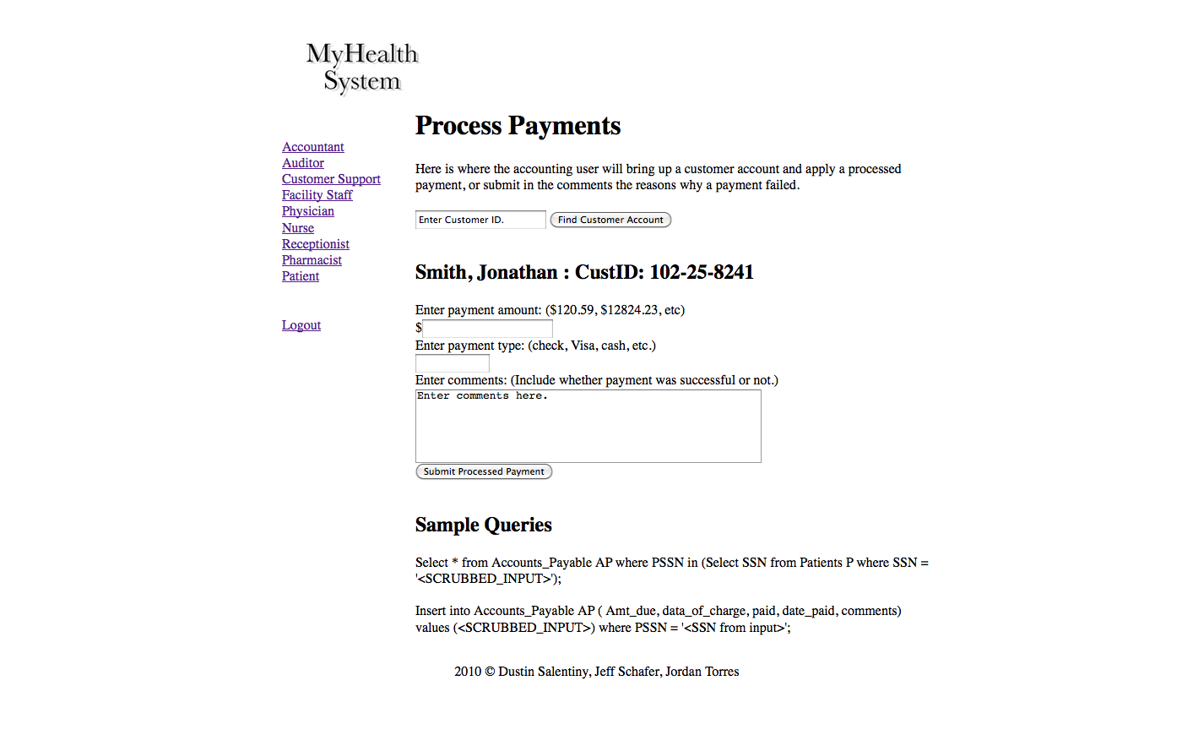

**Figure 8 --** Prototype accountant process payment window.

#### 2.3.4    Verify Account Balance

The accountant task verify account balance is how the user will check the account balance for a patient. The accountant user will enter the patient ID (SSN) and be shown the current balance and the respective billable items. If the patient ID is not found, the system will display an error 'No patient found.' or if there are no billable items for the patient 'No outstanding billable items.'.

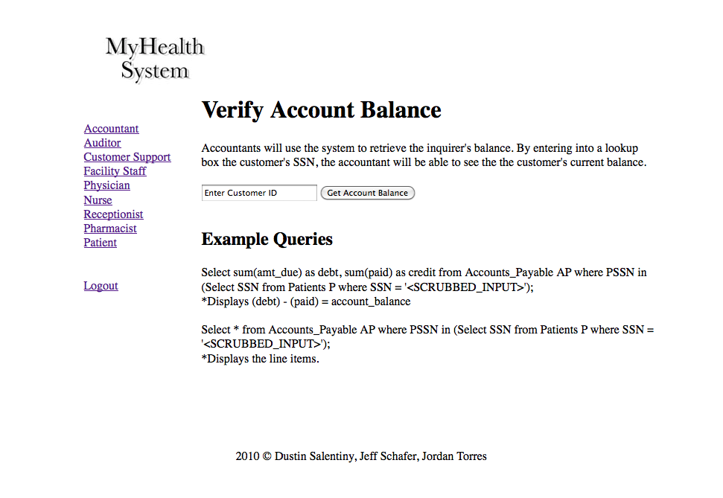

**Figure 9 --** Prototype accountant verify account balance window.

### 2.4    Auditor Windows

#### 2.4.1    Main Menu

The auditor main menu is where users will land if they have chosen the auditor role or are only in one role (auditor). There are two tasks the auditor may perform. Billing Audit and Pharmacy Audit tasks are available by selecting the respective link in the middle of the screen. There are only two other ways of leaving this screen; either by selecting a different role or by clicking on the 'Logout' link of the left-hand side menu.

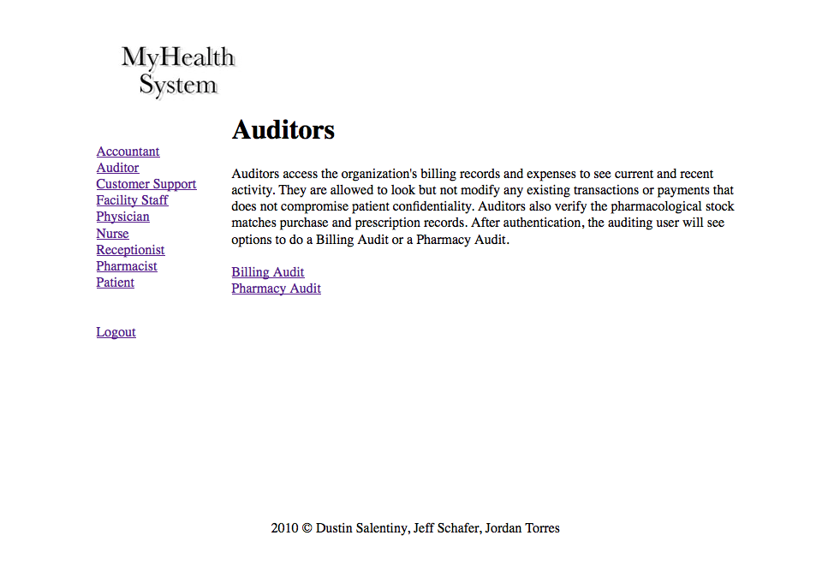

**Figure 10 --** Prototype auditor main menu.

#### 2.4.2    Billing Audit

The auditor task audit billing reports is how the user will generate a billing report for an individual patient. By entering a patient ID (SSN) and clicking on 'Find Billing Report', the system will retrieve a list of billing items from the accounts_payable table. The items are billable items assigned to the patient. If the patient ID is not found, the system will display an error 'No patient found.' or if there are no billable items for the patient 'No outstanding billable items.'.

<insert image of auditor billing audit window>

**Figure 11 --** Prototype auditor billing audit window.

#### 2.4.3    Pharmacy Audit

The auditor task pharmacy audit is how the user will generate an inventory report for a pharmaceutical drug and see the current inventory of the drug. By entering in the drug name, the system will display the closest match or if an exact match will display the current inventory of the drug name. If no drug is found, the error message 'No drug found by that name.' will appear.

<insert image of auditor pharmacy audit window>

**Figure 12 --** Prototype auditor pharmacy audit window.

## 3 Performance Requirements

### 3.1    Development Environment

#### 3.1.1    Database Software

MySQL 5 was chosen for it's low cost and high feature set. The feature set includes ACID transactions, table and index partitioning, unlimited row-level locking, distributed transactions, and more. MySQL supports all necessary functions of the system and has lower minimum system specifications. The installation is quick and relatively painless. MySQL supports SQL-99, stored procedures, triggers, transactions, and many more.

#### 3.1.2    Operating Systems/Server Software

PHP is a web-based programming language. PHP is supported on Windows, Linux, Unix, Solaris, and many other operating systems. See PHP web site (http://www.php.net/) for more information about supported operating systems.

#### 3.1.3    Web Development Tools

X-code, Dreamweaver, Notepad.

### 3.2    Hardware Support

The minimum hardware specifications for hosting this system are based on the operating system used (check operating system documentation for minimum specifications) and the estimated size of clientele. The following specifications are in addition to the minimum operating system specifications. For use with a small clientele base (100 active users at any given time), a minimum of 512 megabytes of memory for the MySQL server, 256 megabytes of memory for the web service, five (5) gigabytes of disk space, and a T1 internet connection (1.5 megabits per second). For use with a large clientele base (3000 active users at any given time), a minimum of four (4) gigabytes of memory for the MySQL server, two (2) gigabytes of memory for the web service, 40 gigabytes of disk space, and a T3 internet connection (44.7 megabits per second).

## 4 Backup and Recovery Requirements

Backup recommendations? How is this addressed?  Suggest backing up the SQL database to a separate server every 1 hour (differential backup) and a full backup each night around 3AM. Weekly or daily backups to remote locations for distributed catastrophe recover system.

The web server should only need backing up once or twice a week. The software will change infrequently. The few changes will likely be software updates deployed by the developers. Before each (automated) deployment, a full system backup should be performed.

## 5 Legal Issues

### 5.1    Privacy

Privacy is one of the most important priorities for the system. Doctors and Nurses will have access to symptoms and diagnosis, but not contact information or other non-essential information. All other staff will have limited access to patient files. For example, a receptionist may check a person's schedule, but not see the patient history. An accountant may see the billable items, but not what was discussed or other private information regarding the billable items.

### 5.2    Security

Security is an important priority for the system. The electronic medical record keeping system utilizes abstract layers of security. The two primary security layers are database and interface. Each layer has secondary levels to further limit access or possible privacy violations. Security of private information is a high priority of the MyHealth System.

The database layer will have secondary layers to allow user types to access or modify certain areas of the database. This also prevents users to view or edit areas of the database they do not have permission to access or modify. By limiting access at the database layer also limits the amount of damage done in the event of nefarious activities at a terminal.

The compounds of the interface security layer are derived from authentication of users to access the system and see level specific information. The authentication process is in the form of passwords or pin numbers to allow users to access certain aspects of the MyHealth System and restrict them from access to others. This system ensures that only the individuals that know the account credentials may access that account.

The aforementioned security protocols were developed to be as transparent as possible while still allowing for maximum patient privacy. By limiting access at a user-type level, the security requirements are reduced for higher layers. By having interface-level security, the number of windows available to a user is limited--which further restricts their actions to the bare-essential screens that user type needs to accomplish their goal. These layers function much like a tree-branching system function. The trunk is the widest access and the primary branches have only specific access to the main trunk. Likewise, the secondary functions only have access to specific parts of the primary branches.

### 5.3    Legality

Any person under the age of 18 will require consent from a parent or guardian. Any mentally disabled person will require consent from a parent or caretaker.

## 6    Full-Size ER Diagram



## 7    Full-Size Schema Diagram

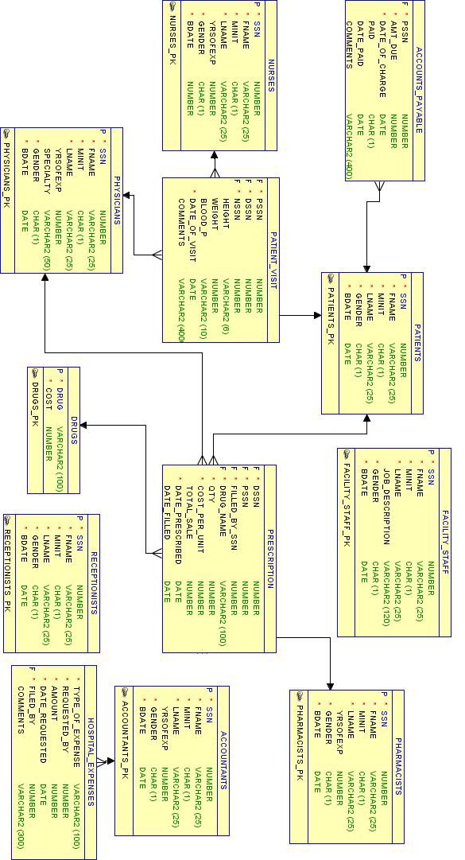

# **EMRKS -- Source Code**

Dustin Salentiny

Jeffrey Schafer

Jordan Torres

**MyHealth® System**

22 April 2010

## 0 Accountant.php

<?php

include("includes.php");

include("header.php");

include("body_start.php");

?>

<h1>Accountants</h1>

    The MyHealth System recognizes an organization's need for proper billing and payment processing. Accountants primary goals include running billing reports, processing payments, and verifying account balances. After authentication, accountant users will see the options to do Billing Reports, Process Payments, and Verify Account Balance.<br /><br />

<a href='billingreports.php'>Billing Reports</a><br />

<a href='processpayments.php'>Process Payments</a><br />

<a href='verifyaccountbalance.php'>Verify Account Balance</a><br />

<?php

include("body_end.php");

include("footer.php");

?>

## 1 Auditor.php

<?php

include("includes.php");

include("header.php");

include("body_start.php");

?>

<h1>Auditors</h1>

    Auditors access the organization's billing records and expenses to see current and recent activity.  They are allowed to look but not modify any existing transactions or payments that does not compromise patient confidentiality. Auditors also verify the pharmacological stock matches purchase and prescription records. After authentication, the auditing user will see options to do a Billing Audit or a Pharmacy Audit.<br /><br />

<a href='billingaudit.php'>Billing Audit</a><br />

<a href='pharmacyaudit.php'>Pharmacy Audit</a><br />

<?php

include("body_end.php");

include("footer.php");

?>

## 2 Authenticate.php

<?php

$trigger = "true";

include("includes.php");

define('SALT_LENGTH', 9);

function generateHash($plainText, $salt = null)

{

    if ($salt === null)

    {

        $salt = substr(md5(uniqid(rand(), true)), 0, SALT_LENGTH);

    }

    else

    {

        $salt = substr($salt, 0, SALT_LENGTH);

    }

    return $salt . sha1($salt . $plainText);

}

$username = md5($_POST['username']);

$password = $_POST['password'];

$_SESSION['username'] = $_POST['username'];

if ($_SESSION['username'] == null || $_SESSION['username'] == "")

{

      $_SESSION['loginerror']="Enter a username.";

      $_SESSION['login']="false";

      SESSION_write_close();

      header("Location: index.php");

      exit();

}

$sql = "select uid, password from users where username = '$username';";

$result = mysql_query($sql) or die("Error in string: $sql. ".mysql_error());

if (mysql_num_rows($result) > 0)

{

   $row = mysql_fetch_row($result);

   $salt = substr($row[1],0,SALT_LENGTH);

   $userpass = substr($row[1],SALT_LENGTH);

   if ($row[1] == generateHash($password,$salt))

   {

      $_SESSION['uid'] = $row[0];

      $_SESSION['login']="true";

      SESSION_write_close();

      header("Location: index.php");

      exit();

   }

   else

   {

      $_SESSION['loginerror']="Incorrect password.";

      $_SESSION['login']="false";

      SESSION_write_close();

      header("Location: index.php");

      exit();

   }

}

else

{

      $_SESSION['loginerror']="Incorrect username.";

      $_SESSION['login']="false";

      SESSION_write_close();

      header("Location: index.php");

      exit();

}

?>

## 3 Billingaudit.php

<?php

include("includes.php");

include("header.php");

include("body_start.php");

?>

<h1>Billing Audits</h1>

        Accessing expense data will be business expenses that the hospital incurs that is applicable to auditing. The billing audit screen will show all of the line items, their corresponding billable amount, and the amount a customer has paid toward the balance. This screen can be sorted by line item type or by date. This list will be read only.

        <?php

$sql = "SELECT p.FNAME,p.LNAME, TYPE_OF_EXPENSE, AMOUNT, DATE_REQUESTED, a.FNAME, a.LNAME, COMMENTS FROM

PHYSICIANS p, ACCOUNTANTS a, HOSPITAL_EXPENSES

WHERE REQUESTED_BY=p.SSN AND FILLED_BY=a.SSN;";

$result = mysql_query($sql) or die("Error in string: $sql. ".mysql_error());

$numrows=mysql_numrows($result);

if ($numrows>0)

{?>

<h1> Hospital Expenses to Date: </h1>

<table border=5;> <tr style='font-weight:bold;'><td>Name</td><td>Expense Type</td><td>Amount</td><td>Date Requested</td>

<td>Approved By</td><td>Comments</td></tr>

<?

 for($i=0;$i<$numrows;$i++)

 {

 $rname = mysql_result($result,$i,0)." ".mysql_result($result,$i,1);

 $fname = mysql_result($result,$i,5)." ".mysql_result($result,$i,6);

 $f1 = mysql_result($result,$i,2);

 $f2 = mysql_result($result,$i,3);

 $f3 = mysql_result($result,$i,4);

 $f4 = mysql_result($result,$i,7);

 echo "<tr><td>$rname</td><td>$f1</td><td> $f2</td><td> $f3</td><td>$fname</td><td> $f4</td></tr>";

 }

}

$sql = "SELECT f.FNAME,f.LNAME, TYPE_OF_EXPENSE, AMOUNT, DATE_REQUESTED, a.FNAME, a.LNAME, COMMENTS FROM

FACILITY_STAFF f, ACCOUNTANTS a, HOSPITAL_EXPENSES

WHERE REQUESTED_BY=f.SSN AND FILLED_BY=a.SSN;";

$result = mysql_query($sql) or die("Error in string: $sql. ".mysql_error());

$numrows=mysql_numrows($result);

if($numrows>0)

{

 for($i=0;$i<$numrows;$i++)

 {

 $rname = mysql_result($result,$i,0)." ".mysql_result($result,$i,1);

 $fname = mysql_result($result,$i,5)." ".mysql_result($result,$i,6);

 $f1 = mysql_result($result,$i,2);

 $f2 = mysql_result($result,$i,3);

 $f3 = mysql_result($result,$i,4);

 $f4 = mysql_result($result,$i,7);

 echo "<tr><td>$rname</td><td>$f1</td><td> $f2</td><td> $f3</td><td>$fname</td><td> $f4</td></tr>";

 }

echo"</table>";

}

include("body_end.php");

include("footer.php");

?>

## 4 Billingreports.php

<?php

include("includes.php");

include("header.php");

include("body_start.php");

?>

<h1>Billing Menu</h1>

On this screen, accounting users will enter the customers ID, which is their SSN, into the lookup box

and see a report of all of the customer's charges in a line by line form. These screens are read-only.

<br><br>

<form name='bills' action='billingreports.php' method='post'>

<input type='text' name='custid' size='20' value='Enter Customer ID'> <input type='submit' value='Find Billing Report'>

<br><br>

        <?php

$custid=$_POST['custid'];

$sql = "select DATE_OF_CHARGE,AMT_DUE, PAID, COMMENTS, FNAME, LNAME from PATIENTS,ACCOUNTS_PAYABLE where ssn=pssn and ssn = '$custid';";

$result = mysql_query($sql) or die("Error in string: $sql. ".mysql_error());

$numrows = mysql_numrows($result);

if ($numrows>0)

{

$fname = mysql_result($result,$i,4);

$lname = mysql_result($result,$i,5);

?>

<h1> <? echo "$fname $lname";?></h1>

<?

echo "<table border=1;> <tr style='font-weight:bold;'><td>Date of Charge</td><td>Amount Billed</td><td>Amount Paid</td><td>Payment Information</td></tr>";

 for($i=0;$i<$numrows;$i++)

 {

 $f1 = mysql_result($result,$i,0);

 $f2 = mysql_result($result,$i,1);

 $f3 = mysql_result($result,$i,2);

 $f4 = mysql_result($result,$i,3);

 echo "<tr><td>$f1</td><td> $f2</td><td> $f3</td><td> $f4</td></tr>";

 echo "       ";

 }

echo"</table>";

}

include("body_end.php");

include("footer.php");

?>

## 5 Body_end.php

<?php

?>

</div>

<div id="body_footer">

<?php

include("body_footer.php");

?>

</div>

## 6 Body_footer.php

<?php

// place for body's footer

?>

## 7 Body_header.php

<?php

// place for main pages header information

?>

## 8 Body_start.php

<?php

?>

<div id="body_header">

<?php

include("body_header.php");

?>

</div>

<div id="menu">

<?php

include("menu.php");

?>

</div>

<div id="content">

## 9 Createaccount.php

<?php

$trigger='true';

include("includes.php");

include("header.php");

include("body_start.php");

?>

<div id='accountcreation'>

<h1>Create an Account</h1>

<form name='createaccount' action='validateaccount.php' method='post'>

First Name:<br>

<input type='text' name='firstname' style='width: 150px;' value='<?php echo $_SESSION['firstname'] ?>'><br>

Middle Name: (Optional)<br>

<input type='text' name='middlename' style='width: 100px;' value='<?php echo $_SESSION['middlename'] ?>'><br>

Last Name:<br>

<input type='text' name='lastname' style='width: 150px;' value='<?php echo $_SESSION['lastname'] ?>'><br>

<br>

Desired Username: (jsmith, etc.) <br>

<input type='text' name='username' style='width: 120px;' value='<?php echo $_SESSION['username'] ?>'><br>

Password:<br>

<input type='text' name='password1' style='width: 150px;' value='<?php echo $_SESSION['password1'] ?>'><br>

Re-type Password:<br>

<input type='text' name='password2' style='width: 150px;' value='<?php echo $_SESSION['password2'] ?>'><br>

<br>

Phone Number:<br>

<input type='text' name='phone' style='width: 115px;' value='<?php echo $_SESSION['phone'] ?>'><br>

E-mail Address:<br>

<input type='text' name='email' style='width: 200px;' value='<?php echo $_SESSION['email'] ?>'><br>

<br>

<em>Anti-bot check</em><br>

Enter one of the following colors: <strong>red</strong>, <strong>green</strong>, <strong>yellow</strong>, or <strong>blue</strong>.<br><br>

<em><?php displayCaptcha(); ?></em><br>

<input type='text' name='address' style='width: 150px;'><br>

<br>

<input type='submit' value='Create Account'>   <a href='index.php'>Cancel</a><br><br>

</form>

</div>

<?php

include("body_end.php");

include("footer.php");

function displayCaptcha()

{

   $pick = rand(5,12);

   if ($pick == 5)

   {

      echo "What color are pine needles?";

      $_SESSION['captcha'] = "green";

   }

   if ($pick == 6)

   {

      echo "What color is the sky?";

      $_SESSION['captcha'] = "blue";

   }

   if ($pick == 7)

   {

      echo "What color is the sun?";

      $_SESSION['captcha'] = "yellow";

   }

   if ($pick == 11)

   {

      echo "What color is a second place ribbon/award?";

      $_SESSION['captcha'] = "red";

   }

   if ($pick == 12)

   {

      echo "What color is a first place ribbon/award?";

      $_SESSION['captcha'] = "blue";

   }

}

?>

## 10 Customersupport.php

<?php

include("includes.php");

include("header.php");

include("body_start.php");

?>

<h1>Customer Support</h1>

Enter in customer ID to get customer profile.

<br>

<form name='add' action='customersupport.php' method='post'>

<? $cust=$_POST['custid'];

$addrow = $_POST['addRow'];

if ($addrow=="Add")

{

$apptDate = $_POST['addApp'];

$time = $_POST['time'];

$sql = "SELECT MAX(visitid) FROM PATIENT_VISIT";

$result=mysql_query($sql) or die("Error in select max routine");

$vid = mysql_result($result,0,0);

$vid=$vid+1;

$sql = "SELECT FNAME, LNAME from PATIENTS where ssn=$cust;";

$result=mysql_query($sql) or die("Error in add routine".mysql_error());

$fname = mysql_result($result,0,0);

$lname = mysql_result($result,0,1);

$sql = "INSERT INTO PATIENT_VISIT(PSSN,DATE_OF_VISIT,TIME,VISITID) VALUES ('$cust','$apptDate', '$time',$vid);";

$result=mysql_query($sql) or die("Error in insert routine".mysql_error());

}

$delrow = $_POST['del'];

if ($delrow!="")

{

$sql = "DELETE FROM PATIENT_VISIT WHERE VISITID=$delrow;";

$result=mysql_query($sql) or die("Error in delete routine".mysql_error());

}?>

<input type='text' name='custid' size='20' value='<? echo "$cust";?>'> <input type='submit' value='Find'>

<br>

<?php

$custid=$_POST['custid'];

$sql = "select FNAME, LNAME, DATE_OF_VISIT, time, visitid from PATIENTS,PATIENT_VISIT

where ssn=pssn and ssn = '$custid';";

$result = mysql_query($sql) or die("Error in string: $sql. ".mysql_error());

$numrows = mysql_numrows($result);

if ($numrows>0)

{

echo "</br>";

echo "<table border=1;> <tr style='font-weight:bold;'><td>Frist Name</td><td>Last Name

</td><td>Appointment Date</td><td>Time</td><td>Delete?</td></tr>";

 for($i=0;$i<$numrows;$i++)

 {

 $f1 = mysql_result($result,$i,0);

 $f2 = mysql_result($result,$i,1);

 $f3 = mysql_result($result,$i,2);

 $f4 = mysql_result($result,$i,3);

 $f5 = mysql_result($result,$i,4);

 echo "<tr><td>$f1</td><td> $f2</td><td> $f3</td><td> $f4</td><td><input type='submit' name='del' value=$f5></input></td></tr>";

 }

echo"</table>";

echo "Appointment Date:<input type='text' name='addApp' size='20'>

<br>

Time:

  <input type='text' name='time' size=15></input>

 <input type='submit' name='addRow' value='Add'>";

}

include("body_end.php");

include("footer.php");

?>

## 11 Database.php

<?php

$dbhost = "svn.serverwench.com";

$dbuser = "emrks";

$dbpass = "emrks77";

$db = "emrksdb";

$dbconnection = mysql_connect($dbhost, $dbuser, $dbpass) or die ("Unable to connect");

mysql_select_db($db) or die ("Unable to select database");

?>

## 12 Facilitystaff.php

<?php

include("includes.php");

include("header.php");

include("body_start.php");

?>

<h1>Facility Staff</h1>

One of the most important priorities for any medical facility is the cleanliness of its rooms. Facility staff primary goals are to clean rooms soon after being vacated, make sure equipment is the proper location, and find equipment that has been requested. After authentication, the facility staff will see options to look up rooms that need cleaning, retrieve equipment move requests, and find equipment location.

<br><br>Rooms That Need Cleaning<br>

        Rooms that are assigned the need for cleaning with a description of the type of cleaning (equipment, floors, bedding, etc) shall be kept in an updated list that is easily marked off by staff as they are done with completion of cleaning. On this screen, the facility staff will be able to see the rooms that need cleaning. After service has been rendered, the user will select the room completion option or select the an option to detail why a room is not clean. Such circumstances may be: the room has a leaky room, the bathroom sink is broken, a floor tile is cracked, etc. Once the room has been repaired, the user will select the room completion option to notify the system of a room available.

<br><br>Retrieve Equipment Move Requests<br>

        Medical staff need equipment and materials to be in a room. The request specifies the equipment and to the room to which it should be moved. The screen will be an ordered list of equipment move requests. The list will be a first come, first serve order. Once the request has been completed, the facility user will choose the request completed option and then next request will be shown.

<br><br>Find Equipment Location<br>

        An online look up system shall be implemented to allow staff to look up equipment location quickly at any network accessible location. This screen will ask for the major equipment ID or equipment name and display a list of equipment and its location. This screen is read only.

<?php

include("body_end.php");

include("footer.php");

?>

## 13 Footer.php

</div>

</center>

</BODY>

</HTML>

## 14 Header.php

<?php

if ($pagetitle == "")

   $pagetitle = "Default title";

?>

<HTML>

<HEAD>

<link rel="stylesheet" type="text/css" href="screen.css" media="screen" />

<link rel="stylesheet" type="text/css" href="print.css" media="print" />

<TITLE><?php echo $pagetitle ?></TITLE>

</HEAD>

<BODY>

<center>

<div id='mainbody'>

## 15 Includes.php

<?php

session_start();

if (($_SESSION['username'] == null || $_SESSION['username'] == "") && $trigger != "true")

{

      $_SESSION['loginerror']="You are not logged in.";

      $_SESSION['login']="false";

      SESSION_write_close();

      header("Location: index.php");

      exit();

}

include("database.php");

?>

## 16 Index.php

<?php

$pagetitle = "Electronic Medical Record Keeping System";

$trigger = "true";

include("includes.php");

include("login.php");

$trigger = "false";

?>

## 17 Login.php

<?php

include("includes.php");

if ($_SESSION['login'] == "true")

{

   header("Location: myaccount.php");

}

include("header.php");

if ($_SESSION['login'] == null || $_SESSION['login'] == "false" || $_SESSION['login'] == "")

{

?>

<div id='mainbodylogin'>

<form name='loginform' action='authenticate.php' method='post'>

<div id='loginbox'>

<div id='loginerror'>

<?php

echo $_SESSION['loginerror'];

$_SESSION['loginerror'] = "";

?>

</div>

<div id='userfield1'>Username: </div><div id='userfield2'><input type='text' name='username' style='width: 150px;' value='<?php echo $_SESSION['username'] ?>'></div>

<div id='passfield1'>Password: </div><div id='passfield2'><input type='password' name='password' style='width: 150px;'></div>

<div id='createfield'><a href='createaccount.php'>Create an account.</a></div>

<div id='loginsubmit'><input type='submit' value='Login'></div>

</form>

</div>

<?php

}

elseif ($_SESSION['login'] == "true")

{

   include("myaccount.php");

}

else

{

   session_destroy();

}

include("footer.php");

?>

## 18 Logout.php

<?php

include("includes.php");

//include("header.php");

session_destroy();

session_start();

$_SESSION['loginerror'] = "Your session has ended.";

$_SESSION['login'] = "false";

header("Location: index.php");

?>

<?php

//include("footer.php");

?>

## 19 Medicalhistory.php

<?php

include("includes.php");

include("header.php");

include("body_start.php");

?>

<h1>Patient Medical History</h1>

<br>Physicians and Nurses may use this screen to retrieve patient history. <br><br>

Enter patient social security number to retrieve patient history.

<br><br>

<form name='history' action='medicalhistory.php' method='post'>

<input type='text' name='custid' size='20' value='Enter Customer ID'> <input type='submit' value='Find Patient History'>

<br><br>

        <?php

$custid=$_POST['custid'];

if ($custid != "" && $custid > 0)

{

$sql = "select pv.HEIGHT, pv.WEIGHT, pv.BLOOD_P, pv.DATE_OF_VISIT, pv.COMMENTS, p.FNAME, p.LNAME, p.MINIT, pv.DSSN, pv.NSSN from PATIENTS as p ,PATIENT_VISIT as pv where p.ssn=pv.pssn and p.ssn = '$custid' ORDER BY DATE_OF_VISIT DESC;";

$result = mysql_query($sql) or die("Error in string: $sql. ".mysql_error());

$numrows = mysql_numrows($result);

if ($numrows>0)

{

$fname = mysql_result($result,$i,5);

$lname = mysql_result($result,$i,6);

$minit = mysql_result($result,$i,7);

?>

<h1> <? echo "$fname $minit. $lname";?></h1>

<?

echo "<table style='border-width=1px;border-spacing:1px;;border-style:solid;border-color:black;'> <tr  bgcolor=lightgray  style='font-weight:bold;'><td>Date of Visit</td><td>Physician</td><td>Nurse</td><td rowspan=2>Details</td></tr><tr><td>Height</td><td>Weight</td><td>Blood Pressure</td></tr>";

for($i=0;$i<$numrows;$i++)

{

$height = mysql_result($result,$i,0);

$weight = mysql_result($result,$i,1);

$blood_p = mysql_result($result,$i,2);

$dateofvisit = mysql_result($result,$i,3);

$comments = mysql_result($result,$i,4);

$doctor = mysql_result($result,$i,8);

$nurse = mysql_result($result,$i,9);

$sql2 = "select CONCAT(FNAME,' ',MINIT,' ',LNAME) from PHYSICIANS where ssn = '$doctor';";

$sql3 = "select CONCAT(FNAME,' ',MINIT,' ',LNAME) from NURSES where ssn = '$nurse';";

$result2 = mysql_query($sql2) or die("Error in string: $sql2. ".mysql_error());

$result3 = mysql_query($sql3) or die("Error in string: $sql3. ".mysql_error());

$doctor = mysql_result($result2,0,0);

$nurse = mysql_result($result3,0,0);

echo "<tr bgcolor=lightgray><td> <strong>$dateofvisit</strong></td><td> <strong>Dr. $doctor</strong></td><td> <strong>$nurse</strong></td><td rowspan=2> $comments</td></tr><tr><td>$height</td><td> $weight</td><td> $blood_p</td></tr>";

  echo "       ";

  }

echo"</table>";

}

else

{

echo "Patient history for ID# $custid not found!";

}

}

elseif ($custid == "" && $custid <= 0)

{

}

else

{

}

include("body_end.php");

include("footer.php");

?>

## 20 Menu.php

<?php

if ($_SESSION['login'] == "true")

{

?>

<a href="accountant.php">Accountant</a><br>

<a href="auditor.php">Auditor</a><br>

<a href="customersupport.php">Customer Support</a><br>

<a href="facilitystaff.php">Facility Staff</a><br>

<a href="physician.php">Physician</a><br>

<a href="nurse.php">Nurse</a><br>

<a href="receptionist.php">Receptionist</a><br>

<a href="pharmacist.php">Pharmacist</a><br>

<a href="patient.php">Patient</a><br>

<br><br>

<a href="logout.php">Logout</a><br>

<?php

}

?>

## 21 Myaccount.php

<?php

include("includes.php");

include("header.php");

include("body_start.php");

?>

<h1>Main Menu</h1>

Select a menu item from the left.<br />

<br />

<b>Developers note:</b> Users will only see options for which they have access.

<?php

include("body_end.php");

include("footer.php");

?>

## 22 Nurse.php

<?php

include("includes.php");

include("header.php");

include("body_start.php");

?>

<h1>Nurses</h1>

<br>Nurses are responsible for the well-being and early seeing of the patients.  As such they will have access to the patients files to prep them before being seen by a doctor or physician. Nurses also enter details about their interactions with patients. After authentication, nurses will be able to do patient record retrieval and do a patient visitation detail submission.

<br><br>

<a href='medicalhistory.php'>View Patient Medical History</a><br />

<a href='submitvisit.php'>Enter Patient Visit Details</a><br />

<?php

include("body_end.php");

include("footer.php");

?>

## 23 Patient.php

<?php

include("includes.php");

include("header.php");

include("body_start.php");

?>

<h1>Patients</h1>

    Patients are the primary focus of this hospital.  They are the ones tended to and need to have access to their own files but no one else's.  They also should be able to see their files online and to schedule/cancel appointments online, pay bills etc.<br>

<br>

<a href='patienthistory.php'>View Medical History</a><br />

<a href='patientscheduling.php'>Schedule an appointment</a><br />

<?php

include("body_end.php");

include("footer.php");

?>

## 24 Patienthistory.php

<?php

include("includes.php");

include("header.php");

include("body_start.php");

?>

<h1>Patient Medical History</h1>

<br>Patient may use this screen to retrieve patient history. <br>

        An online viewing system will be set up with authorization that the patient can review their own medical history and medical files. Patient history will include all relevant medical history data.  Relevant medical history includes: blood pressure, cholesterol, height, weight, surgeries, date of visit, prescribed medicine, notes, and allergies.

        <?php

$custid=$_SESSION['uid'];

if ($custid != "" && $custid > 0)

{

$sql = "select pv.HEIGHT, pv.WEIGHT, pv.BLOOD_P, pv.DATE_OF_VISIT, pv.COMMENTS, p.FNAME, p.LNAME, p.MINIT, pv.DSSN, pv.NSSN from PATIENTS as p ,PATIENT_VISIT as pv where p.ssn=pv.pssn and p.ssn = '$custid' ORDER BY DATE_OF_VISIT DESC;";

$result = mysql_query($sql) or die("Error in string: $sql. ".mysql_error());

$numrows = mysql_numrows($result);

if ($numrows>0)

{

$fname = mysql_result($result,$i,5);

$lname = mysql_result($result,$i,6);

$minit = mysql_result($result,$i,7);

?>

<h1> <? echo "$fname $minit. $lname";?></h1>

<?

echo "<table style='border-width=1px;border-spacing:1px;;border-style:solid;border-color:black;'> <tr  bgcolor=lightgray  style='font-weight:bold;'><td>Date of Visit</td><td>Physician</td><td>Nurse</td><td rowspan=2>Details</td></tr><tr><td>Height</td><td>Weight</td><td>Blood Pressure</td></tr>";

for($i=0;$i<$numrows;$i++)

{

$height = mysql_result($result,$i,0);

$weight = mysql_result($result,$i,1);

$blood_p = mysql_result($result,$i,2);

$dateofvisit = mysql_result($result,$i,3);

$comments = mysql_result($result,$i,4);

$doctor = mysql_result($result,$i,8);

$nurse = mysql_result($result,$i,9);

$sql2 = "select CONCAT(FNAME,' ',MINIT,' ',LNAME) from PHYSICIANS where ssn = '$doctor';";

$sql3 = "select CONCAT(FNAME,' ',MINIT,' ',LNAME) from NURSES where ssn = '$nurse';";

$result2 = mysql_query($sql2) or die("Error in string: $sql2. ".mysql_error());

$result3 = mysql_query($sql3) or die("Error in string: $sql3. ".mysql_error());

$doctor = mysql_result($result2,0,0);

$nurse = mysql_result($result3,0,0);

echo "<tr bgcolor=lightgray><td> <strong>$dateofvisit</strong></td><td> <strong>Dr. $doctor</strong></td><td> <strong>$nurse</strong></td><td rowspan=2> $comments</td></tr><tr><td>$height</td><td> $weight</td><td> $blood_p</td></tr>";

  echo "       ";

  }

echo"</table>";

}

else

{

echo "Patient history for ID# $custid not found!";

}

}

elseif ($custid == "" && $custid <= 0)

{

}

else

{

}

include("body_end.php");

include("footer.php");

?>

## 25 Patientscheduling.php

<?php

include("includes.php");

include("header.php");

include("body_start.php");

?>

<h1>Patient Scheduling</h1>

          Patients will, with proper authentication, be able to view their upcoming appointments and request to modify them to cancel/reschedule according to time-slots available with their doctor/physician. Upon approval they will receive an email, mail, or telephone call notifying them of the changes.

<br>

<?php

include("body_end.php");

include("footer.php");

?>

## 26 Pharmacist.php

<?php

include("includes.php");

include("header.php");

include("body_start.php");

?>

<h1>Pharmacists</h1>

    Pharmacists are responsible for the administration of drugs with proper forms given by a doctor.  As doctors fill out prescriptions (online or by paper) the pharmacists are allowed to check and see prescriptions for patients and give out the medicine as needed. Pharmacists will also need to update inventory when new shipments arrive.

<br><br>

<a href='rxcheck.php'>View Patient Prescriptions</a><br />

<a href='rxinventory.php'>View Inventory</a><br />

<?php

include("body_end.php");

include("footer.php");

?>

## 27 Pharmacyaudit.php

<?php

include("includes.php");

include("header.php");

include("body_start.php");

?>

<h1>Pharmacy Audits</h1>

        Accessing and tracking prescriptions and pharmacological stock. The pharmacy audit screen will show, for each pharmacological item, the pharmacy's purchased amount, the current inventory amount, and the amount prescribed. The audit user will be able to view an entire history of a pharmacological item by selecting it from the list. This history will show chronologically the inventory levels, including purchases, prescriptions, or expirations.

        <?php

$sql = "SELECT p.FNAME,p.LNAME, TYPE_OF_EXPENSE, AMOUNT, DATE_REQUESTED, a.FNAME, a.LNAME, COMMENTS FROM

PHARMACISTS p, ACCOUNTANTS a, HOSPITAL_EXPENSES

WHERE REQUESTED_BY=p.SSN AND FILLED_BY=a.SSN;";

$result = mysql_query($sql) or die("Error in string: $sql. ".mysql_error());

$numrows=mysql_numrows($result);

if ($numrows>0)

{?>

<h1> Pharmacy Expenses to Date: </h1>

<table border=3;> <tr style='font-weight:bold;'><td>Name</td><td>Expense Type</td><td>Amount</td><td>Date Requested</td>

<td>Approved By</td><td>Comments</td></tr>

<?

 for($i=0;$i<$numrows;$i++)

 {

 $rname = mysql_result($result,$i,0)." ".mysql_result($result,$i,1);

 $fname = mysql_result($result,$i,5)." ".mysql_result($result,$i,6);

 $f1 = mysql_result($result,$i,2);

 $f2 = mysql_result($result,$i,3);

 $f3 = mysql_result($result,$i,4);

 $f4 = mysql_result($result,$i,7);

 echo "<tr><td>$rname</td><td>$f1</td><td> $f2</td><td> $f3</td><td>$fname</td><td> $f4</td></tr>";

 }

echo "</table>";

}

include("body_end.php");

include("footer.php");

?>

## 28 Physician.php

<?php

include("includes.php");

include("header.php");

include("body_start.php");

?>

<h1>Physicians</h1>

<br>Physicians include doctors and pediatricians.  They are responsible, along with nurses, for caring for the patients.  As the doctors see patients they will have access to patient medical history and be responsible for electronically logging the details of the most previous patient visit.  However, they will not have access to things such as patient financial information.  Physicians will enter patient visit details after the visitation has ended.

<br><br>

<a href='medicalhistory.php'>View Patient Medical History</a><br />

<a href='submitvisit.php'>Enter Patient Visit Details</a><br />

<?php

include("body_end.php");

include("footer.php");

?>

## 29 Print.css

body

{

   background-color: white;

}

#mainbody

{

   border-width: 0px;

   border-style: solid;

   border-color: black;

   position: relative;

   text-align: left;

   width: 760px;

   height: 90%;

   text-size: 12pt;

   background-image: url('images/logo1.jpg');

   background-repeat: no-repeat;

   background-position: top left;

}

#mainbodylogin

{

   border-width: 0px;

   border-style: solid;

   border-color: black;

   position: relative;

   text-align: left;

   width: 760px;

   height: 100%;

   text-size: 12pt;

   background-color: white;

   background-image: url('images/logo2.jpg');

   background-repeat: no-repeat;

   background-position: left center;

}

#loginbox

{

   position: absolute;

   top: 50%;

   margin-left: 15em;

   margin-top: -5em;

   width: 250px;

   text-align: right;

   border-width: 0px;

   border-style: solid;

   border-color: black;

   padding: 10px;

}

#loginerror

{

   color: red;

   font-weight: bolder;

   font-size: 10pt;

   font-family: arial;

}

#userfield1

{

   float: left;

   text-align: right;

   text-size: 10pt;

   font-family: arial;

}

#userfield2

{

   text-align: right;

   text-size: 10pt;

   font-family: arial;

}

#passfield1

{

   float: left;

   text-align: right;

   text-size: 10pt;

   font-family: arial;

}

#passfield2

{

   text-align: right;

   text-size: 10pt;

   font-family: arial;

}

#createfield

{

   float: left;

   text-align: right;

   font-size: 8pt;

   margin-top: 7px;

   font-family: arial;

}

#submitlogin

{

   width: 55px;

   float: right;

   text-align: right;

}

#body_header {

/*  background: #EEEEEE; */

  position: absolute;

  top: 0px;

  left: 1px;

  width: 620px;

  height: 100px;

}

#menu {

/*  background: #EEEEEE; */

  display:none;

  position: absolute;

  top: 170px;

  left: 0px;

  width: 0=1px;

  height: 500px;

  padding-left: 7px;

}

#content {

/*  background: #fff; */

  position: absolute;

  top: 100px;

  left: 1px;

  width: 760px;

  height: 500px;

  padding-left: 15px;

  padding-top: 15px;

  padding-bottom: 15px;

}

#body_footer {

/*  background: #DDDDDD; */

  position: absolute;

  top: 500px;

  left: 0px;

  width: 760px;

  height: 100px;

  text-align: center;

}

#copyright

{

  position: relative;

  bottom: 0px;

   text-align: center;

   width: 100%;

}

## 30 Processpayments.php

<?php

include("includes.php");

include("header.php");

include("body_start.php");

?>

<h1>Process Payments</h1>

Here is where the accounting user will bring up a customer account and apply a processed payment, or submit in the comments the reasons

why a payment failed.

<br><br>

<form name='getrecords' action='processpayments.php' method='post'>

<input type='text' name='custid' value='Enter Customer ID.'> <input type='submit' value='Find Customer Account'>

<br><br>

<?php

$custnum=$_POST['custid'];

$sql = "select DATE_OF_CHARGE,AMT_DUE, PAID,DATE_PAID, COMMENTS, PAY_ID, FNAME, LNAME, MINIT from PATIENTS,ACCOUNTS_PAYABLE where ssn=pssn and ssn = '$custnum';";

$result = mysql_query($sql) or die("Error in string: $sql. ".mysql_error());

$num=mysql_numrows($result);

if ($num>0)

{

$fname = mysql_result ($result,0,6);

$lname = mysql_result ($result,0,7);

$minit = mysql_result ($result,0,8);

?>

<h2><? echo "$lname, $fname $minit.";?> </h2>

<?

echo "<table border=1;> <tr style='font-weight:bold;'><td>Date of Charge</td><td>Amount Billed</td><td>Amount Paid</td><td>Date Paid</td><td>Payment Information</td><td>Select One</td></tr>";

 for($i=0;$i<$num;$i++)

 {

 $f1 = mysql_result($result,$i,0);

 $f2 = mysql_result($result,$i,1);

 $f3 = mysql_result($result,$i,2);

 $f4 = mysql_result($result,$i,3);

 $f5 = mysql_result($result,$i,4);

 $f6 = mysql_result($result,$i,5);

 echo "<tr><td>$f1</td><td> $f2</td><td> $f3</td><td> $f4</td><td>$f5</td><td><input type='radio' name='WhichPayment' value='$f6' ></input></td></tr>";

 }

echo"</table>";

}

?>

<br><br></br></br></br>

Enter payment amount: ($120.59, $12824.23, etc)<br>

<input type='text' name='payment' size='20'> <br>

Enter payment type: (check, Visa, cash, etc.)<br>

<input type='text' name='payment_type' size='10'><br>

Enter comments: (Include whether payment was successful or not.)<br>

<textarea rows='5' name='comments' cols='50'>Enter comments here.</textarea><br>

<input type='submit' name='Process' value='Submit Processed Payment'>

<br><br>

<?

$button = $_POST['Process'];

if ($button == 'Submit Processed Payment');

{

$amt_paid=$_POST['payment'];

$comments=$_POST['payment_type'].". ".$_POST['comments'];

$id=$_POST['WhichPayment'];

$sql = "UPDATE ACCOUNTS_PAYABLE SET PAID='$amt_paid', DATE_PAID=CURDATE(), COMMENTS='$comments' WHERE PAY_ID='$id';";

$result = mysql_query($sql) or die("Error in string: $sql. ".mysql_error());

}

?>

        <?php

include("body_end.php");

include("footer.php");

?>

## 31 Receptionist.php

<?php

include("includes.php");

include("header.php");

include("body_start.php");

?>

9    Receptionists

    Receptionists are responsible for maintaining the scheduling of patients with the nurses and physicians.  They should be allowed to update the scheduling but not see things such as patient medical history. Receptionists sometimes will need to handle patient payment requests.  Receptionists, after logging in, will be able to access a screen which will allow them to enter a patient's SSN or MYID which will grant them an easy access view of the patient's schedule.

    9.1    Patient Scheduling

        Receptionists are able to access a patient's schedule after entering the patient's SSN or MYID into a lookup box and submitting it. They are then able to update their requests for them if necessary.  If the patient has electronically requested an update the receptionist is responsible for allowing the change and notifying the patient and personnel necessary. As requests come in the receptionist will be able to confirm or deny the updated change.  After either is selected the patient will be notified via email and telephone to let the patient know what decision they made and why.

    9.2    Registering Payment

        A patient may pay during their visit. The payment must be logged and pended to their account. Payment processing is done by accountants.  If a patient is willing to pay during a visit to the hospital they may pay the receptionist.  The receptionist is able to log into the system and access a patients billing screen by entering their SSN or MYID.  From the billing screen they are able to update pending payments as the balance is adjusted with confirmed payments.

<?php

include("body_end.php");

include("footer.php");

?>

## 32 Rxcheck.php

<?php

include("includes.php");

include("header.php");

include("body_start.php");

?>

<h1>Prescription Check</h1>

        Pharmacists will have limited access to an online page to see if the patient has the requested prescription approved by the doctor or not. The doctor must have administered it, and approved it, then marked a check box to authorize it as a digital signature. The pharmacist will be able to log in and put in the patient's SSN or MYID and be able to pull up their past and current prescription requests along with who administered them, the dosage, the medicine and the digital signature from the prescribing doctor. As prescriptions are filled, inventory is automatically updated as the pharmacist must close out the request for the medicine by either allowing it or denying it.

<br><br>

<form name='rx' action='rxcheck.php' method='post'>

<input type='text' name='custid' size='20' value='Enter Customer ID'> <input type='submit' value='Find Patient Prescriptions'>

<br><br>

        <?php

$custid=$_POST['custid'];

if ($custid != "" && $custid > 0)

{

$sql = "select pv.DSSN, pv.FILLED_BY_SSN, pv.DRUG_NAME, pv.DATE_OF_VISIT, pv.COMMENTS, p.FNAME, p.LNAME, p.MINIT from PATIENTS as p ,PRESCRIPTION as pv where p.ssn=pv.pssn and p.ssn = '$custid' ORDER BY DATE_OF_VISIT DESC;";

$result = mysql_query($sql) or die("Error in string: $sql. ".mysql_error());

$numrows = mysql_numrows($result);

if ($numrows>0)

{

$fname = mysql_result($result,$i,5);

$lname = mysql_result($result,$i,6);

$minit = mysql_result($result,$i,7);

?>

<h1> <? echo "$fname $minit. $lname";?></h1>

<?

echo "<table style='border-width=1px;border-spacing:1px;;border-style:solid;border-color:black;'> <tr  bgcolor=lightgray  style='font-weight:bold;'><td>Date of Prescription</td><td>Physician</td><td>Pharmacist</td><td>Drug name</td></tr><tr><td colspan=4>Details</td></tr>";

for($i=0;$i<$numrows;$i++)

{

$drugname = mysql_result($result,$i,2);

$dateofvisit = mysql_result($result,$i,3);

$comments = mysql_result($result,$i,4);

$doctor = mysql_result($result,$i,0);

$pharm = mysql_result($result,$i,1);

$sql2 = "select CONCAT(FNAME,' ',MINIT,' ',LNAME) from PHYSICIANS where ssn = '$doctor';";

$sql3 = "select CONCAT(FNAME,' ',MINIT,' ',LNAME) from PHARMACISTS where ssn = '$pharm';";

$result2 = mysql_query($sql2) or die("Error in string: $sql2. ".mysql_error());

$result3 = mysql_query($sql3) or die("Error in string: $sql3. ".mysql_error());

$doctor = mysql_result($result2,0,0);

$pharm = mysql_result($result3,0,0);

echo "<tr bgcolor=lightgray><td> <strong>$dateofvisit</strong></td><td> Dr. $doctor</td><td> $pharm</td><td><strong>$drugname</strong></td></tr><tr><td colspan=4> $comments</td></tr>";

  echo "       ";

  }

echo"</table>";

}

else

{

echo "Patient prescriptions for ID# $custid: none found!";

}

}

elseif ($custid == "" && $custid <= 0)

{

}

else

{

}

include("body_end.php");

include("footer.php");

?>

## 33 Rxinventory.php

<?php

include("includes.php");

include("header.php");

include("body_start.php");

?>

<h1>Pharmacological Inventory</h1>

        Pharmacists will need to maintain an up-to-date inventory. When new stock arrives, it will need to be entered into the system in a spreadsheet type format page online.  There will be a page which will tell of current medical stock, if the pharmacist wants to make any changes, and an update section will allow them to increase stock as new stock comes in.

<br><br>

<form name='rx' action='rxinventory.php' method='post'>

<input type='text' name='drugname' size='20' value='Enter drug name'> <input type='submit' value='Find Inventory'>

<br><br>

        <?php

$drug=$_POST['drugname'];

if ($drug != "")

{

$sql = "select DRUGS, COST, QUANTITY from DRUGS where DRUGS like '%$drug%';";

$result = mysql_query($sql) or die("Error in string: $sql. ".mysql_error());

$numrows = mysql_numrows($result);

if ($numrows>0)

{

?>

        <br /><br /><table border=1><tr bgcolor="lightgray"><td>Drug Name</td><td>Cost</td><td>Quantity</td></tr>

<?

$count = 0;

for($i=0;$i<$numrows;$i++)

 {

  $dname = mysql_result($result,$i,0);

$dcost = mysql_result($result,$i,1);

$dqty = mysql_result($result,$i,2);

echo "<tr><td>$dname</td><td>$dcost</td><td>$dqty</td></tr>";

 }

 ?>

 </table>

 <?

}

}

?>

</form>

<?

include("body_end.php");

include("footer.php");

?>

## 34 Screen.css

body

{

   background-color: white;

}

#mainbody

{

   border-width: 0px;

   border-style: solid;

   border-color: black;

   position: relative;

   text-align: left;

   width: 760px;

   height: 100%;

   text-size: 12pt;

   background-image: url('images/logo1.jpg');

   background-repeat: no-repeat;

   background-position: top left;

}

#mainbodylogin

{

   border-width: 0px;

   border-style: solid;

   border-color: black;

   position: relative;

   text-align: left;

   width: 760px;

   height: 100%;

   text-size: 12pt;

   background-color: white;

   background-image: url('images/logo2.jpg');

   background-repeat: no-repeat;

   background-position: left center;

}

#loginbox

{

   position: absolute;

   top: 50%;

   margin-left: 15em;

   margin-top: -5em;

   width: 250px;

   text-align: right;

   border-width: 0px;

   border-style: solid;

   border-color: black;

   padding: 10px;

}

#loginerror

{

   color: red;

   font-weight: bolder;

   font-size: 10pt;

   font-family: arial;

}

#userfield1

{

   float: left;

   text-align: right;

   text-size: 10pt;

   font-family: arial;

}

#userfield2

{

   text-align: right;

   text-size: 10pt;

   font-family: arial;

}

#passfield1

{

   float: left;

   text-align: right;

   text-size: 10pt;

   font-family: arial;

}

#passfield2

{

   text-align: right;

   text-size: 10pt;

   font-family: arial;

}

#createfield

{

   float: left;

   text-align: right;

   font-size: 8pt;

   margin-top: 7px;

   font-family: arial;

}

#submitlogin

{

   width: 55px;

   float: right;

   text-align: right;

}

#body_header {

/*  background: #EEEEEE; */

  position: absolute;

  top: 0px;

  left: 150px;

  width: 620px;

  height: 100px;

}

#menu {

/*  background: #EEEEEE; */

  position: absolute;

  top: 170px;

  left: 0px;

  width: 150px;

  height: 500px;

  padding-left: 7px;

}

#content {

/*  background: #fff; */

  position: absolute;

  top: 100px;

  left: 150px;

  width: 610px;

  height: 500px;

  padding-left: 15px;

  padding-top: 15px;

  padding-bottom: 15px;

}

#body_footer {

/*  background: #DDDDDD; */

  position: absolute;

  top: 500px;

  left: 0px;

  width: 760px;

  height: 100px;

  text-align: center;

}

#copyright

{

  position: relative;

  bottom: 0px;

   text-align: center;

   width: 100%;

}

## 35 Submitvisit.php

<?php

include("includes.php");

include("header.php");

include("body_start.php");

?>

<h1>Patient Visit Details Submission</h1>

<br>Need description and instructions.

<br><br>

<form name='updateappointment' action='submitvisit.php' method='post'>

<input type='text' name='custid' value='Enter Customer ID'> <input type='submit' value='Find Customer Appointment'>

<br><br>

<?php

$custnum=$_POST['custid'];

$sql = "select DATE_OF_VISIT,HEIGHT, WEIGHT,BLOOD_P, COMMENTS, visitid, FNAME, LNAME, MINIT from PATIENTS,PATIENT_VISIT where ssn=pssn and ssn = '$custnum' order by DATE_OF_VISIT desc;";

$result = mysql_query($sql) or die("Error in string: $sql. ".mysql_error());

$num=mysql_numrows($result);

if ($num>0)

{

$fname = mysql_result ($result,0,6);

$lname = mysql_result ($result,0,7);

$minit = mysql_result ($result,0,8);

?>

<h2><? echo "$lname, $fname $minit.";?> </h2>

<?

echo "<table border=1;> <tr style='font-weight:bold;'><td>Date of Visit</td><td>Height</td><td>Weight</td><td>Blood Pressure</td><td>Comments</td><td>Select One</td></tr>";

 for($i=0;$i<$num;$i++)

 {

 $f1 = mysql_result($result,$i,0);

 $f2 = mysql_result($result,$i,1);

 $f3 = mysql_result($result,$i,2);

 $f4 = mysql_result($result,$i,3);

 $f5 = mysql_result($result,$i,4);

 $f6 = mysql_result($result,$i,5);

 echo "<tr><td>$f1</td><td> $f2</td><td> $f3</td><td> $f4</td><td>$f5</td><td><input type='radio' name='WhichAppointment' value='$f6' ></input></td></tr>";

 }

echo"</table>";

?>

<br><br></br>

Height:<br>

<input type='text' name='height' size='20'> <br>

Weight:<br>

<input type='text' name='weight' size='20'> <br>

Blood Pressure<br>

<input type='text' name='bloodpressure' size='10'><br>

Enter comments: (be detailed.)<br>

<textarea rows='5' name='comments' cols='50'></textarea><br>

<input type='submit' name='process' value='Submit Patient Report'>

<br><br>

<?

}

?>

<?

$button = $_POST['process'];

if ($button == 'Submit Patient Report');

{

$height=$_POST['height'];

$weight=$_POST['weight'];

$bp=$_POST['bloodpressure'];

$comments=$_POST['comments'];

$id=$_POST['WhichAppointment'];

$sql = "UPDATE PATIENT_VISIT SET ";

if ($height != "")

{

$sql=$sql."HEIGHT='$height', ";

}

else

{

$sql=$sql."HEIGHT=HEIGHT, ";

}

if ($weight != "")

{

$sql=$sql."WEIGHT='$weight', ";

}

else

{

$sql=$sql."WEIGHT=WEIGHT, ";

}

if ($bp != "")

{

$sql=$sql."BLOOD_P='$bp', ";

}

else

{

$sql=$sql."BLOOD_P=BLOOD_P, ";

}

$sql=$sql." COMMENTS=if(COMMENTS is null,CONCAT(CURDATE(),':<br>','$comments','<br>'),CONCAT(COMMENTS,CONCAT('<br>',CURDATE(),':<br>'),'$comments','<br>'))  WHERE visitid='$id';";

$result = mysql_query($sql) or die("Error in string: $sql. ".mysql_error());

}

?>

</form>

<?php

include("body_end.php");

include("footer.php");

?>

## 36 Validateaccount.php

<?php

include("includes.php");

include("header.php");

include("body_start.php");

?>

<?php

include("body_end.php");

include("footer.php");

?>

## 37 Verifyaccountbalance.php

<?php

include("includes.php");

include("header.php");

include("body_start.php");

?>

<h1>Verify Account Balance</h1>

Accountants will use the system to retrieve the inquirer's balance. By entering into a lookup box the customer's SSN, the accountant will be able to see the the customer's current balance.

<br><br>

<form name='verifybalance' action='verifyaccountbalance.php' method='post'>

<input type='text' name='custid' size='20' value='Enter Customer ID'> <input type='submit' value='Get Account Balance'>

<br><br>

    <?php

$custid=$_POST['custid'];

$sql = "select fname,lname,SUM(AMT_DUE) as Debt, SUM(PAID) as Credit, SUM(AMT_DUE)-SUM(PAID) as Remaining_Balance from PATIENTS,ACCOUNTS_PAYABLE where ssn=pssn and ssn = '$custid';";

$result = mysql_query($sql) or die("Error in string: $sql. ".mysql_error());

$numrows = mysql_numrows($result);

if ($numrows>0)

{

$fname = mysql_result($result,$i,0);

$lname = mysql_result($result,$i,1);

?>

 <h1>

  <? echo "$fname $lname";?>

 </h1>

<?

echo "<table border=1;> <tr style='font-weight:bold;'><td>Debt</td><td>Paid</td><td>Remaining Balance</td></tr>";

 for($i=0;$i<$numrows;$i++)

 {

 $f1 = mysql_result($result,$i,2);

 $f2 = mysql_result($result,$i,3);

 $f3 = mysql_result($result,$i,4);

 echo "<tr><td>$f1</td><td> $f2</td><td> $f3</td></tr>";

 echo "       ";

 }

echo"</table>";

}

?>

        <?php

include("body_end.php");

include("footer.php");

?>